Module code: 4FTC2113
Course work 3 Mental health Data Analysis
Student code: 25001700
Student Name: Yadavi Shreedhar
Contents
INTRODUCTION 1
DATA DESCRIPTION 2
METHODOLOGY 2
Data Preprocessing and Feature Engineering 2
Modelling Approach 3
RESULTS 3
Class distribution 3
Confusion Matrix 4
Correlation Matrix 4
ROC Curve 5
Feature importance 5
Model Validity and Data Leakage 5
DISCUSSIONS 6
Limitations 6
Future suggestions 6
GIT WORKFLOW 6
REFERENCES 6

INTRODUCTION
Mental health is just as crucial as physical health, but many people overlook mental health issues without seeking professional help. Many individuals lack self-awareness, as they are unable to identify their issues. Understanding the factors that influence treatment-seeking behavior is crucial to improving access to mental health support and designing effective public health interventions.
This study aims to develop a predictive model that identifies whether an individual is likely to seek mental health treatment based on demographic, lifestyle, and psychological factors. Through applying machine learning techniques to a dataset. This report explores the connections between the variables, such as stress level, sleep patterns, physical activity, depression, anxiety, and social support, and their influence on treatment-seeking decisions.
The findings of this study can contribute to a better understanding of mental health and behavior patterns and may support healthcare professionals and policymakers in identifying the individuals who may benefit from targeted mental health resources.

DATA DESCRIPTION
The dataset used in this study is the Sleep Health and Lifestyle Dataset obtained from Kaggle. It contains information related to individuals’ mental health, lifestyle habits, and productivity. This dataset includes both numerical and categorical variables.
Key variables in the dataset include:
- Demographic factors: age, gender, employment status, and work environment.
- Mental health indicators: stress level, depression score, anxiety score, and mental health history.
- Lifestyle factors: sleep hours, physical activity days, and social support score.
- Outcome variable: seeks_treatment (Yes/No), which indicates whether the individual sought mental health treatment.
The dataset provides a suitable foundation for predictive modelling, as it contains multiple relevant features that may influence treatment-seeking behavior.

METHODOLOGY

Data Preprocessing and Feature Engineering
Prior to modelling, several cleaning and preprocessing steps were implemented to ensure data quality and modelling:
- Data Preprocessing and Cleaning:
- As this dataset is obtained from Kaggle, it has already been cleaned, and it has no missing values or duplicates. For preprocessing the data, the gender column is differentiated into male, female, and non-binary, and rather not say, and for a better understanding, the value counts and different terms were identified. The other columns were also preprocessed for better outputs.
- Feature Engineering:
To enhance the predictive power of the model, new variables were created:
- Mental Health Composite Score: calculated as depression_score + anxiety_score – social_support_score, capturing overall psychological burden adjusted for social support.
- Sleep-Activity Ratio: defined as sleep hours divided by (physical activity days + 1), representing a balance between rest and activity.
- Stress Level Capping: extreme outliers in stress levels were capped using the interquartile range (IQR) method to reduce their influence on the model.
- Stress Category: stress levels were categorized into Low, Medium, and High groups to capture non-linear relationships
3.Encoding Categorical Variables:
- Categorical variables such as gender, employment status, work environment, mental health history, and mental health risk level were changed using one-hot encoding to enable numerical processing by machine learning algorithms for modelling.
4.Data Splitting and Scaling:
- The dataset was divided into training (80%) and testing (20%) sets using stratified sampling to preserve class balance. Numerical features were standardized using StandardScaler to ensure equal weighting in the model.

Modelling Approach
A logistic regression model was selected for this modeling due to its interpretability and the suitability of the binary classification issues. The model was trained with balance class weights to address the class imbalance in the data, which is visible as 39.9% positive cases in the training data. It estimates the probability of an individual seeking treatment based on the input features.

RESULTS

Class distribution
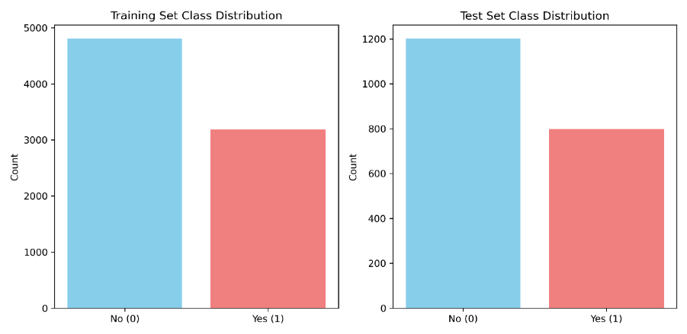
Figure 1 Class distribution bar chart
The image is a bar chart displaying the class distribution for a dataset, split between a training set and a test set. Both the training and test sets maintain the same proportion of class distribution: 60% for Class 0 and 40% for Class 1, indicating a stratified split. The total sample sizes are 8,000 for training and 2,000 for testing.

Confusion Matrix
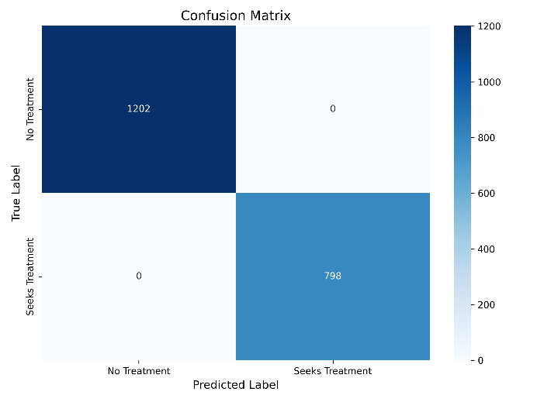
Figure 2 Confusion matrix
This image shows a confusion matrix for a binary classification model. The rows represent the true labels, and the columns represent the predicted labels. The model achieved perfect classification with no false positives and no false negatives. As we can see the matrix is 100% which suggests that either a highly separable dataset and a possible overfitting or a very well accurate model.

Correlation Matrix
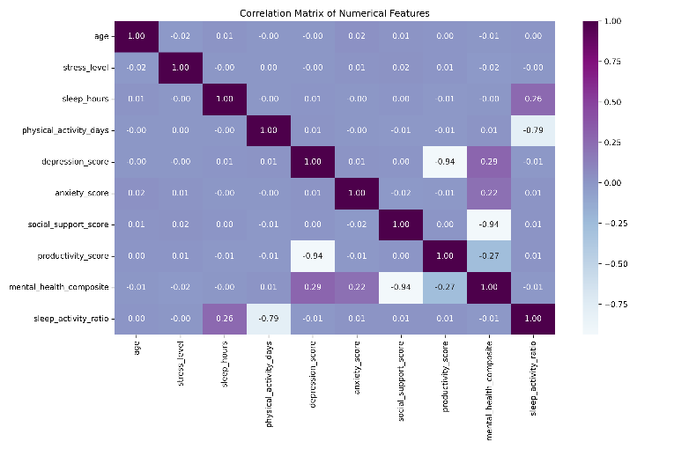
Figure 3 Correlation Matrix
This image displays a correlation matrix for 10 variables related to mental health and lifestyle. The values range from -1 to 1, indicating the strength and direction of linear relationships. The generally weak correlations suggests that the treatment seeking behavior is not driven by simple linear relationships.
Key correlations observed:
- sleep_activity_ratio is strongly negatively correlated with social support, physical activity, and overall mental health.
- stress_level is moderately negatively correlated with productivity and social support.
- The matrix suggests that certain lifestyle and mental health factors are interrelated, but many variables are independent of each other.

ROC Curve

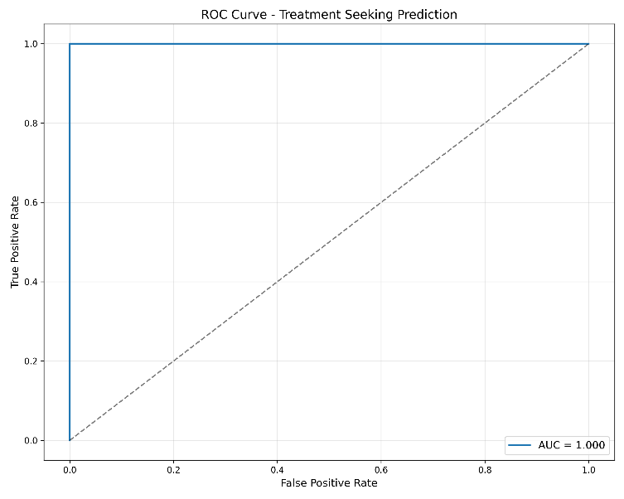
Figure 4 ROC curve
This Receiver Operating Characteristic (ROC) curve for the model. The. It reveals separability between classes, which further supports the presence of data leakage
Key observations:
- The curve is not a typical smooth ROC curve instead, it shows: an FPR = 0.00 for all TPR values from 0.00 to 0.98, Then a single step to FPR = 1.00, TPR = 1.00
- Interpretation: While this appears ideal, given the feature importance finding, this perfect ROC curve is likely a result of data leakage rather than genuine model performance.

Feature importance
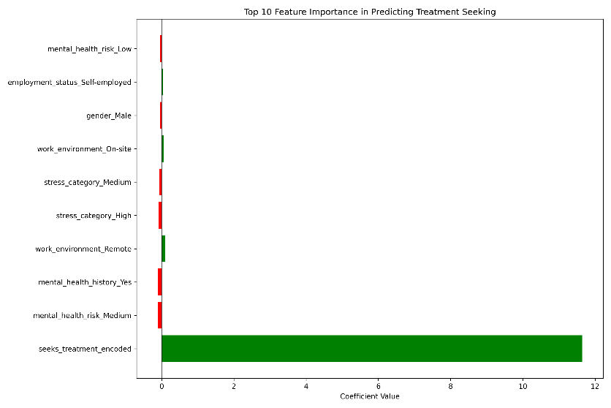
Figure 5 Feature importance
This image displays the coefficient values (likely from a logistic regression model) for various features, indicating their importance and direction of influence on the target variable ("Seeks Treatment"). The presence of seeks_treatment_encoded with a coefficient of 11.50 is a clear red flag for target leakage, invalidating the model's apparent perfect performance.

Model Validity and Data Leakage
The inclusion of the target-variable seeks-treatment-encoded during the experimentation resulted in a data leakage and an artificially perfect model performance with an accuracy and ROC-AUC with 1.00. After the identifying the problem, it was acknowledged that this perfect classification is not realistic for real world tasks. It shows the importance of the feature selection and validation in machine learning models. This demonstrates that high performance does not necessarily imply a valid or generalizable model.

DISCUSSIONS
The results reveal that the treatment seeking behavior can’t be explained only by the variables, as it’s also shown by weak correlations and non-significant test results. It is visible that the model heavily relied on categorical and engineering features such as work environment, mental health risk classification, and stress categories.
The perfect model performance suggests that the dataset contains very strong patterns or potentially overlapping information between the features and the target variable. While this leads to excellent predictive accuracy, it also raises concerns about possible data leakage or redundancy in the dataset, as we can see the modelling results. From a practical perspective, the findings highlight that workplace environment, perceived mental health risk, and broader lifestyle factors may play a significant role in whether individuals seek treatment. Interestingly, categorical and engineered features such as work environment, stress category, and mental health risk level contributed more significantly to prediction than raw psychological scores. This suggests that the contextual and environmental factors may play an important role in influencing whether individuals seek treatment.

Limitations
- The dataset maybe synthetic or semi synthetic
- Self-reported variables may introduce a bias
- Cultural and financial factors were not considered

Future suggestions
Use other models as random forest or other models with nonlinear models. Use larger, real-world datasets in the future.

GIT WORKFLOW
Git was used for version control throughout the project. Regular commits were made at key stages, including data cleaning, feature engineering, exploratory analysis, and model training. Clear commit messages documented progress, and the final notebook and report were uploaded to a GitHub repository to ensure reproducibility and transparency.

REFERENCES
Mashayekhi, M. (2025). Mental Health. [online] Kaggle.com. Available at: https://www.kaggle.com/datasets/mahdimashayekhi/mental-health.
scikit-learn (2014). LogisticRegression. [online] Scikit-learn.org. Available at: https://scikit-learn.org/stable/modules/generated/sklearn.linear_model.LogisticRegression.html.

‌scikit-learn.org. (n.d.). scikit-learn: machine learning in Python — scikit-learn 0.24.1 documentation. [online] Available at: http://scikit-learn.org/.

‌

‌

‌

